Ideation Phase
Define the Problem Statements

Date | 31 January 2025
Team ID | LTVIP2026TMIDS66408
Project Name | Asset Management Portal
Maximum Marks | 2 Marks
Customer Problem Statement Template:
Create a problem statement to understand the challenges organizations face in managing their assets. This template helps focus on key issues like tracking, maintenance, and data accuracy in asset management.
A clear customer problem statement helps teams find better solutions through an Asset Management Portal while understanding user needs, improving efficiency, and supporting effective asset control.
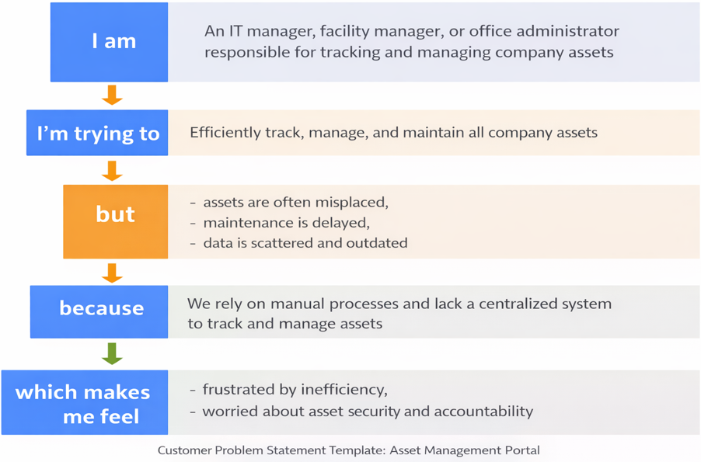
Reference: https://miro.com/templates/customer-problem-statement/
Example:

Problem Statement (PS) | I am (Customer) | I’m trying to | But | Because | Which makes me feel
PS-1 | Asset manager | Track Assets | Data nit updated | No central system | Frustrated
PS-2 | IT manager | Maintain assets | Maintenance delayed | Manual process | stressed

